OFF THAT COUCH FITNESS
Your Training App
Proposal & Engagement Agreement — Phase 1, iOS and Android
Prepared for | Off That Couch Fitness · Steve Clark
Prepared by | Nile Technologies
Re | A training app carrying the OTCF coaching library, wearable data, nutrition and an AI coach
Status | Proposal & engagement agreement — for review and signature
1. Client brief
Off That Couch Fitness is a hands-on endurance coaching business in the United Kingdom, run by Steve Clark — British Triathlon Level 2 Diploma and TrainingPeaks Level 2 certified. Alongside triathlon coaching it delivers personal training, swim coaching and video analysis, sports massage, hydrotherapy and aqua running, blood lactate and VO2 testing, Wattbike FTP testing, bike box hire, a club membership tier and a sponsored race team.
The brief was direct: build an app in the spirit of transition.fun — AI-assisted endurance training — and tell us what it would take. Two things became clear in discussion, and they shape everything in this document:
- It is for anybody, not only OTCF's existing athletes. The app is open and self-serve. Someone can find it, sign up, subscribe and get value without ever meeting Steve.
- Steve's coaching knowledge is the asset. The methodology, the plans and the way he explains a session are what make this app different from anything else on the store. The app's job is to carry that to people at a scale one coach never could.
This proposal covers Phase 1 — a complete, launchable product on both app stores. It is offered in two options, which differ by a single module.
2. Concept note
Today's fitness market is split into three categories that do not talk to each other. Each solves a third of the problem and leaves the athlete to join the rest up by hand.
Category | What it gives you | What it leaves out
Training plan apps | A structured plan for one activity, and analysis of the training you do | What you eat, how you slept, and any real conversation about it
Fitness trackers | Steps, heart rate, sleep, workouts, recovery scores | A plan to follow, coaching, and any nutrition management
Nutrition apps | Food logging, calories and macros | What you are training for — so the targets never move with your training
Your app sits in the middle of all three. Someone picks a guide from your library, connects the watch they already own, photographs what they eat, and talks to a coach that can see all of it at once. Each of those four things exists elsewhere. What does not exist elsewhere is the join between them — nutrition targets that move with the day's training, and a coach that can explain a bad session by looking at the fuelling and the sleep behind it.
That join is the product. Everything in the next section exists to serve it.
3. What the app does
Everything that follows is what your app does for the people who use it — the training you already deliver, in their pocket, with their watch and their food alongside it. One module is marked Option 2; everything else is in both options. Screens shown are from the working design.
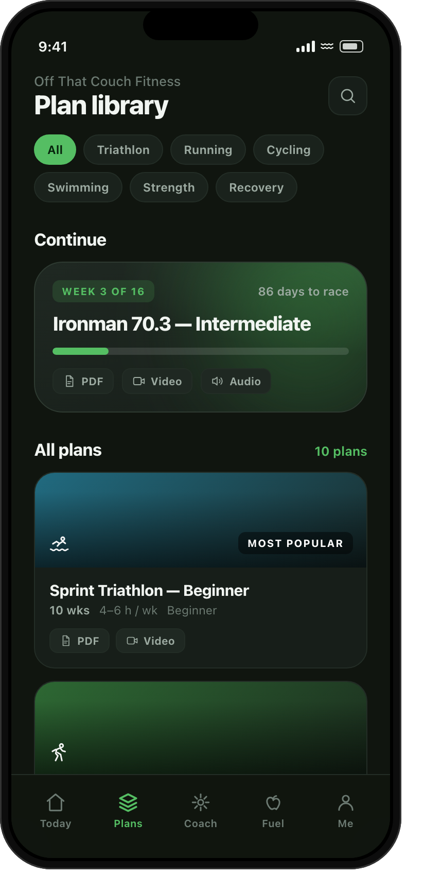 | 1. Your Training Library  - Every discipline you coach — triathlon, running, cycling, swimming, strength and recovery  - Each guide delivered three ways: PDF to read, video to watch, audio to listen to on the bike  - Split into modules with chapter markers, so people pick up where they left off  - Downloadable notes for training without signal  - You set what is free and what is paid, guide by guide | 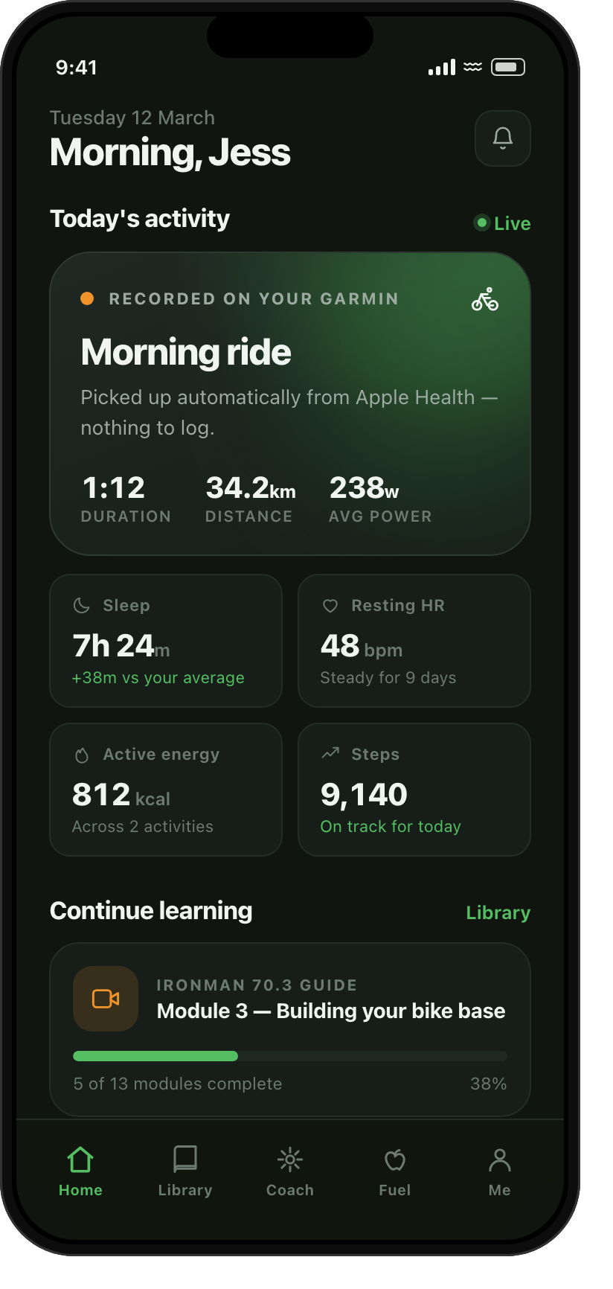 | 2. Wearable & Health Tracking  - Their watch connects once, then simply works — nothing to type in, ever  - Garmin, Apple Watch, Coros, Polar, Whoop, Fitbit, Suunto and more  - Workouts, distance, pace, power and heart rate captured automatically  - Sleep, resting heart rate, steps and daily energy  - Weight and body composition tracked over time
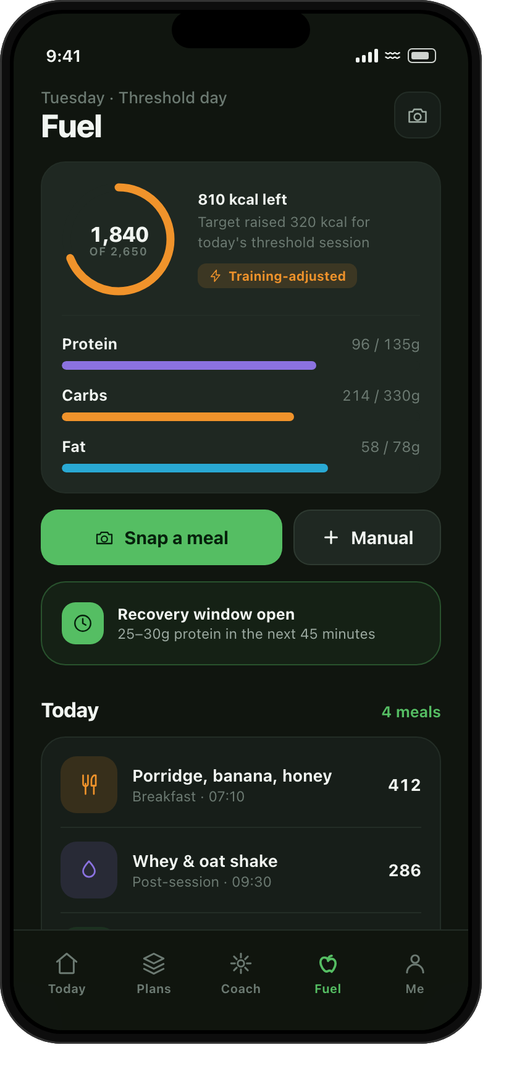 | 3. Nutrition  - Photograph a meal and it is logged — the app identifies the food and the portions  - Or simply describe it: "chicken salad and a banana"  - Calories, protein, carbs and fat against daily targets  - Targets rise on hard training days and settle on easy ones  - Fuelling guidance before, during and after a session | 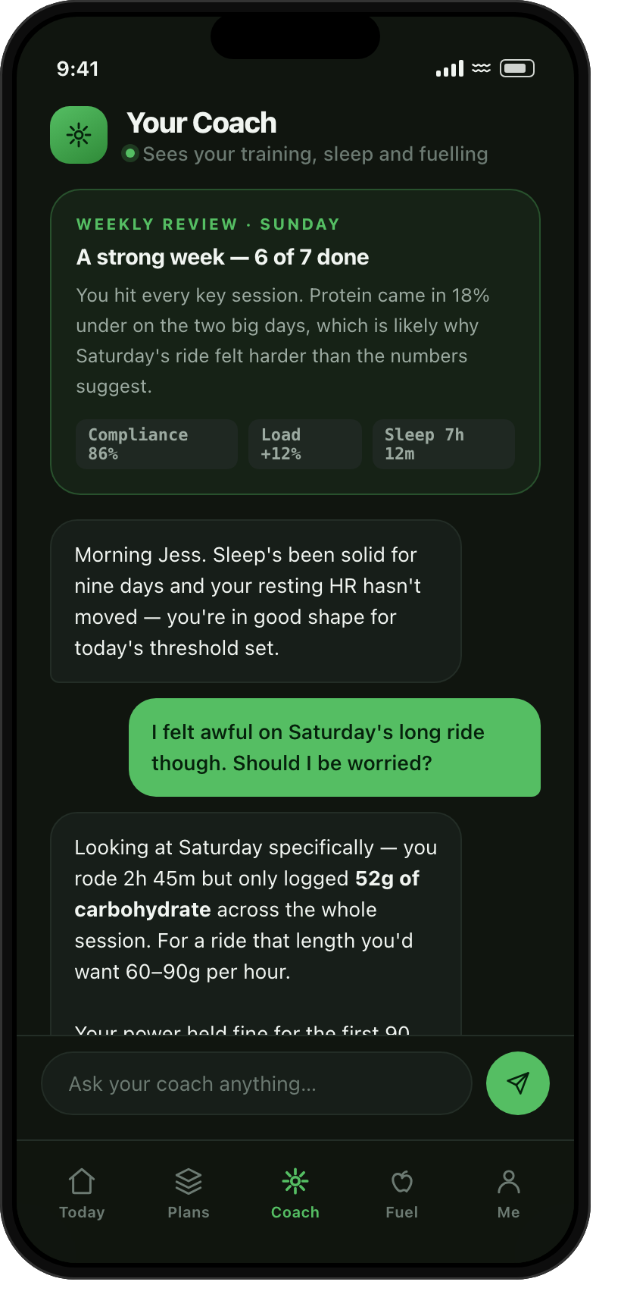 | 4. Your AI Coach  - Answers questions in plain English, at any hour, in your coaching voice  - Reads training, sleep and nutrition together — never one in isolation  - Can explain why a ride felt terrible by looking at what they ate and how they slept  - An automatic weekly review of how the week actually went  - Points them to the right guide in your library when it spots something

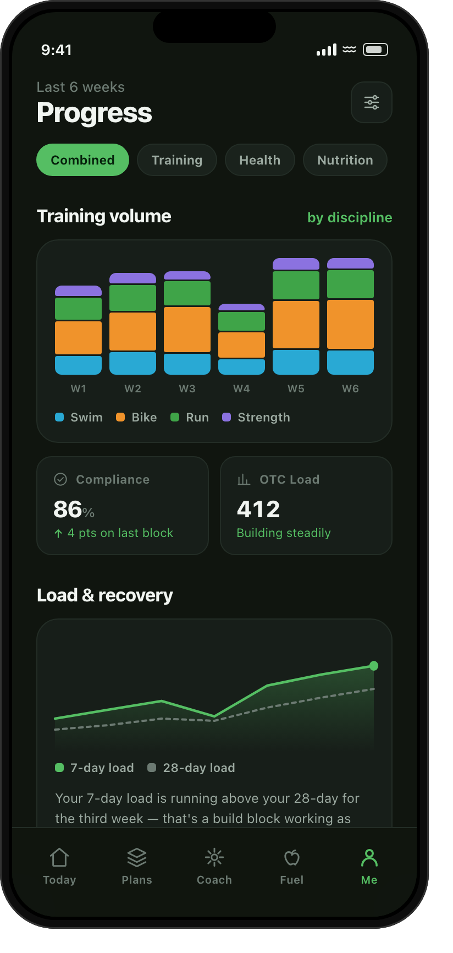 | 5. Progress & Analytics  - Training volume by discipline, week on week  - Training load and recovery trends over time  - Sleep, resting heart rate and weight trends  - The combined view — fuelling set against training load, on one chart  - Personal bests and test results kept in one place | 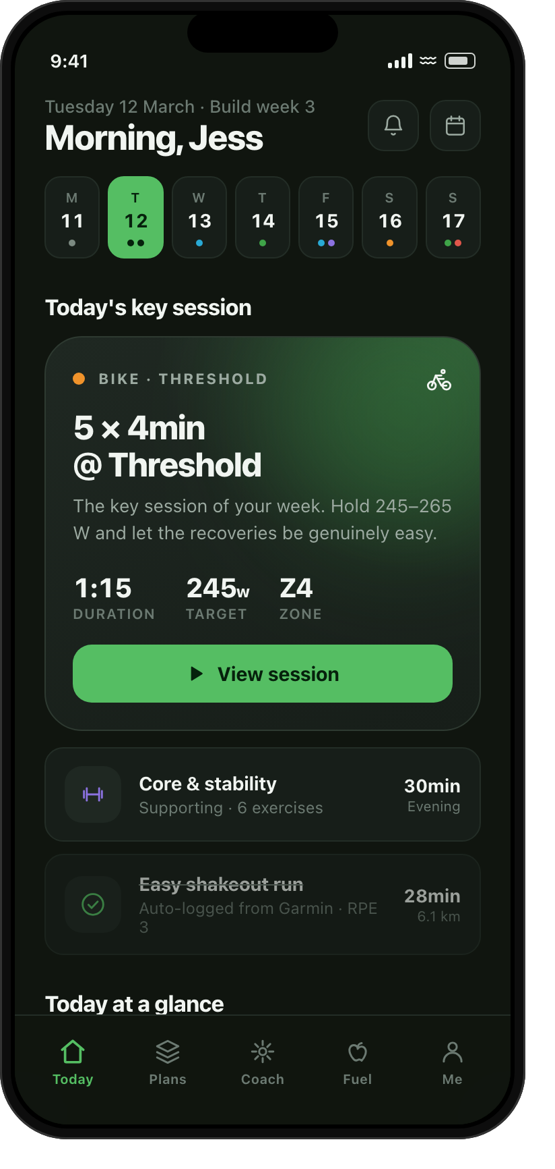 | 6. Guided Plans & Weekly Tasks [ OPTION 2 ]  - You build structured training plans for each category you coach  - People activate a plan and it shapes itself around their race date and available days  - Their training tasks arrive week by week, day by day  - Every session laid out step by step, in their own paces, powers and heart rates  - They tick each one off — or it logs itself the moment their watch syncs  - A full calendar, and the freedom to move a session when life gets in the way
7. Your Admin Console  - Publish and update every guide, video, PDF and audio file yourself  - Organise content into modules and reorder it whenever you like  - Set what is free and what is paid, per guide  - Manage users, subscriptions and access  - Build and publish training plans [ Option 2 ]  - See how people are using the app and what they are working through | 8. The Essentials  - Apps for both iPhone and Android, from a single build  - Full light and dark modes, designed around your brand and logo  - Accounts with email, Sign in with Apple and Google  - Push notifications to keep people coming back  - Subscriptions, free trial and billing handled properly  - Onboarding, health screening and privacy controls to UK standards  - Submitted and launched on the App Store and Google Play
4. A day in the app
The whole product is built around one simple loop that repeats every day and needs almost nothing from the person using it.
Train → It logs itself → Photograph your food → Ask your coach → See the week
They train. Outdoors, in the pool, on the turbo — using whatever watch or bike computer they already own. The app does not need to be open.
It logs itself. The moment the watch syncs, the session appears — duration, distance, pace, power, heart rate. In Option 2 it also ticks off the training task it matches.
They eat. A photograph is enough. The app identifies the food, estimates the portions, and updates the day's calories and macros against a target that already knows how hard they trained.
They ask. Anything, in plain English. Because the coach can see training, sleep and nutrition together, the answers are about them specifically — not general advice.
They see the week. A weekly review arrives without being asked for: what was done, how it is trending, and the one thing worth fixing next week.
5. Choosing your option
Both options are the same app. The difference is one module.
Option 1 — Library Led  They choose what to work on, and when.  - Your full training library — PDF, video and audio  - Wearable and health tracking  - The complete nutrition module  - Your AI Coach  - Progress and analytics  - Your admin console  - Everything in "The Essentials" | Option 2 — Plan & Task Led  Everything in Option 1, plus you guide them week by week.  - Everything listed in Option 1, and:  - Structured training plans you build per category  - People activate a plan, shaped to their race date  - Weekly training tasks, delivered day by day  - Session-by-session detail in their own zones  - Mark complete, or auto-logged from their watch  - Calendar, rescheduling and consistency reporting
Option 2 contains everything in Option 1. Starting with Option 1 discards nothing — the plan layer sits on top of the library rather than replacing it, and is also the groundwork for sending workouts to devices in a later phase.
6. Technology
Chosen so the app is fast to build, inexpensive to run, and straightforward for anyone to maintain in future.
Layer | Technology | Why
Mobile apps | React Native (Expo) | One codebase, two stores. Native feel on iPhone and Android without paying to build it twice.
Back end / API | Node.js serverless functions | Lightweight and scales with your subscriber base rather than ahead of it.
Database | PostgreSQL (Supabase), UK/EU region | Relational fit for users, content, plans and logs. Per-user isolation enforced at the database.
Accounts | Managed auth with Sign in with Apple and Google | Secure sign-in without building it from scratch.
Health data | Native health-platform integration on iOS and Android | The supported, first-party route into workout, heart rate and sleep data from every major device brand.
AI | Claude API — Sonnet for coaching, vision for meal photos | Best-in-class reasoning for coaching conversation, and accurate food recognition from a single photo.
Content delivery | Managed storage with CDN | Your PDFs, videos and audio load quickly anywhere, and stream rather than download.
Subscriptions | Apple In-App Purchase and Google Play Billing | The compliant route for selling subscriptions in both stores.
Privacy | Encryption at rest, UK/EU hosting, in-app export and delete | Health data handled to UK standards from day one.
A note on AI running costs: the Claude API is billed per use and sits outside the build price, alongside hosting and the app store developer accounts. It scales with how many people use the app, and we build in per-user limits from day one so the cost always stays proportionate to your subscription revenue. We will size it precisely with you before launch.
7. Investment
Phase 1 build — fixed fee | Option 1 | Option 2
Design, build, testing and launch of everything shown in this document, on both iOS and Android | £9,300 | £13,700
8. Payment terms
Payments are milestone-based, in the ratio 30 : 30 : 30 : 10.
Milestone | %
On signing, to begin | 30%
Design complete and approved | 30%
Build complete, submitted for your testing | 30%
Live on the App Store and Google Play | 10%
Total | 100%

9. The Nile Promise
We know a build like this evolves as we learn the detail of how you coach. So we make you a simple promise: the refinements, adjustments and natural back-and-forth of getting your app right — within the scope described in this document — will not cost you anything extra. The fee is the fee. If, together, we ever decide to add something genuinely new and beyond this scope, we will simply agree it in a short written add-on before starting — never a surprise. This is our written assurance to you.
10. What we need from you
- Your training content — the guides, plans and coaching material that make the app yours.
- One point of contact for decisions, and feedback at each stage.
- Apple and Google developer accounts opened in the Off That Couch Fitness name.
11. Assumptions
- This proposal covers Phase 1 as described. Later phases — including sending structured workouts out to Garmin and other devices — are scoped and quoted separately.
- Training content, guides and coaching material are authored by Off That Couch Fitness; we design, build and publish the system that carries them.
- The app launches in English (UK), metric by default with an imperial toggle.
- App store developer accounts are held in the Off That Couch Fitness name, so the apps and all subscription revenue belong to you.
- Running costs — developer accounts, hosting and AI usage — are billed separately at cost.
12. Terms
Ownership. On full payment, the delivered app — its code and design — belongs to Off That Couch Fitness. Your coaching content, methodology and all user data remain yours throughout.
Warranty and support. For 3 months (90 days) after launch we will provide handholding and stabilisation support for free.
13. Next steps
Choose your option below and sign, and we will book a content session to map your coaching material into the app and confirm firm dates at kickoff. We are genuinely looking forward to building this with you.
14. Acceptance & signatures
Agreed and accepted on the terms set out in this Proposal & Engagement Agreement:
Option selected: ☐ Option 1 — Library Led ☐ Option 2 — Plan & Task Led
For Off That Couch Fitness  Signature: ___________________________  Name: ___________________________  Date: ___________________________ | For Nile Technologies  Signature: ___________________________  Name: ___________________________  Date: ___________________________

